Circuit Analysis Lab 4
Construction of Circuits:
Proteus Circuit:
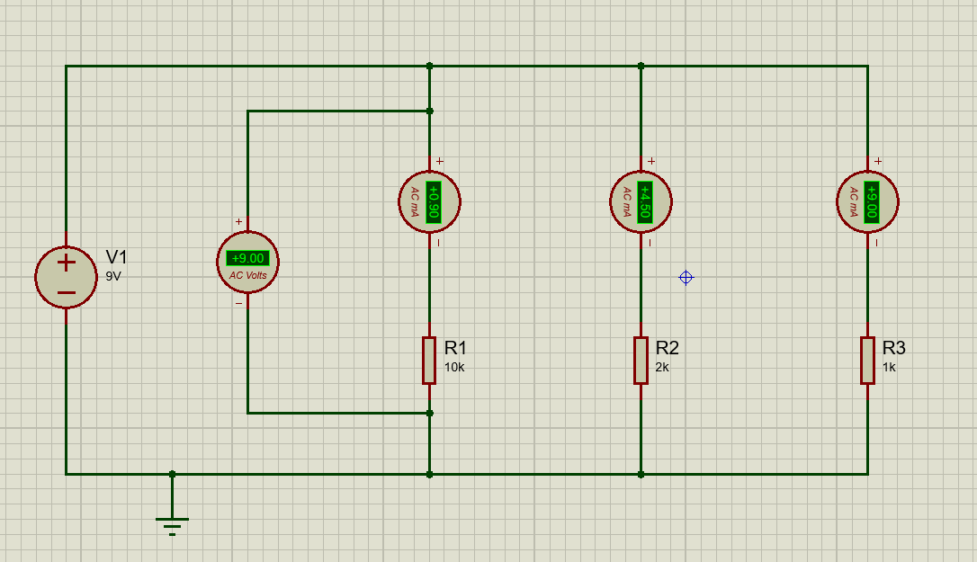

Explanation:
1. Take a DC source (9V battery) and draw two main horizontal lines (top and bottom) to form parallel branches
2. Connect the positive terminal of the battery to the top horizontal line and the negative terminal to the bottom line
3. In the first vertical branch, connect an ammeter in series and then connect resistor R1 (10 kΩ) to the bottom line
4. In the second vertical branch, connect another ammeter in series and then connect resistor R2 (2 kΩ) to the bottom line
5. In the third vertical branch, connect another ammeter in series and then connect resistor R3 (1 kΩ) to the bottom line
6. Connect a voltmeter in parallel across one branch (top line to bottom line) to measure the supply voltage
7. Join all lower ends of resistors to the bottom line to complete each branch
8. Connect the bottom line to ground as a reference point
9. Ensure all three resistors are connected in parallel between the same two nodes (top and bottom lines) so current divides in each branch.

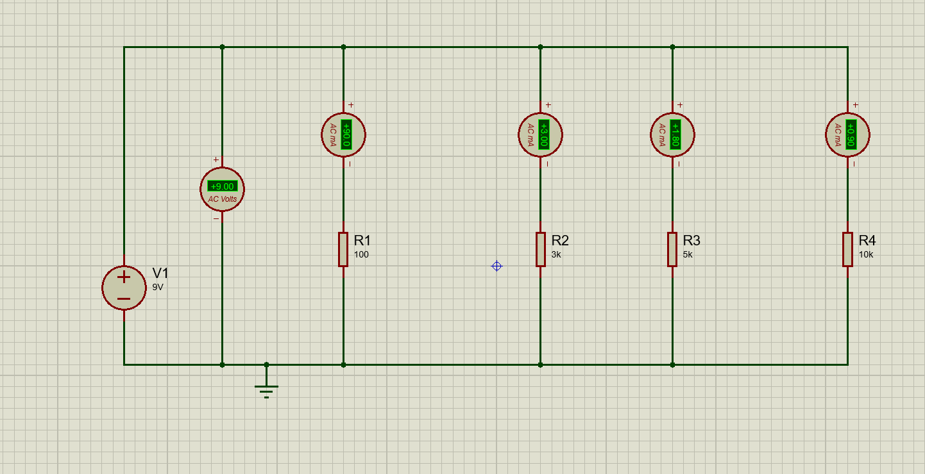
Proteus Circuit:

Explanation:
1. Take a DC source (9V battery) and draw two main horizontal lines (top and bottom) to form parallel branches
2. Connect the positive terminal of the battery to the top horizontal line and the negative terminal to the bottom line
3. In the first vertical branch, connect an ammeter in series and then connect resistor R1 (100Ω) to the bottom line
4. In the second vertical branch, connect another ammeter in series and then connect resistor R2 (3 kΩ) to the bottom line
5. In the third vertical branch, connect another ammeter in series and then connect resistor R3 (5 kΩ) to the bottom line
6. In the fourth vertical branch, connect another ammeter in series and then connect resistor R4 (10 kΩ) to the bottom line
6. Connect a voltmeter in parallel across one branch (between 1st node and 2nd node) to measure the supply voltage
7. Join all lower ends of resistors to the bottom line to complete each branch
8. Connect the bottom line to ground as a reference point
9. Ensure all three resistors are connected in parallel between the same two nodes (top and bottom lines) so current divides in each branch.

